­­

**Finch Bay Galapagos Diving Programme**

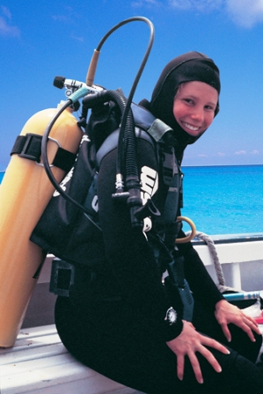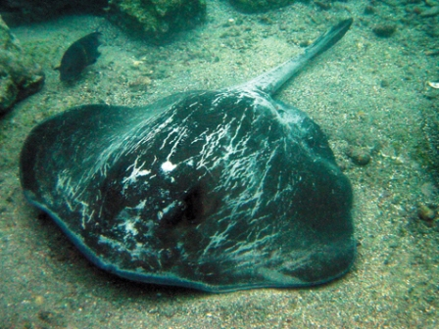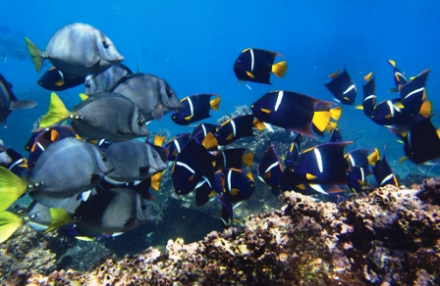**5 Days/ 4 Nights**

You haven't experienced the Galapagos until you see what's below the water! The diving is truly world class and often rumoured by pro divers to be completely unique.

The Finch Bay Eco Hotel offers PADI-designed programmes to allow guests to experience the thrill of scuba diving in a safe and fun environment. This diving package was designed by pro divers to highlight the best the Galapagos has to offer. A comprehensive underwater experience for the adventurous divers that want to take home unforgettable memories. Most dive sites within the central islands are included, making this package a complete winner.

**Highlights:**

North Seymour, Daphne Minor, and the always amazing Gordon Rocks. Right on Santa Cruz, a visit to the Charles Darwin Research Station; home of the captive-rearing program for the famous giant tortoises. Full scuba gear provided.

***Dive sites (number of dives per site):***

Some of the dive sites may include: North Seymour (2), Daphne Minor (1), Mosquera Islet (1), and Gordon Rocks (2).

***Note:*** Dive sites may be changed due to sea conditions, availability National Park restrictions or safety requirements

**Species which can be observed:**

Among other marine life that can be found in the Galapagos Marine Reserve we find: large Galapagos garden eel colonies, sea turtles, rays, yellowtail grunts, bigeye jacks, and schools of snappers. We also have frequent sightings of shark, snake eels, sea turtles, mantas, amberjacks, barracudas. And often, we get to play with the many sea lions which reside on the beach and observe tropical fish, multicolored sponges, moray eel, octopus, and more.

* Rays: Eagle and Manta Rays, Stingrays
* Sharks: Hammerheads, White-Tipped Reef Sharks, Galapagos Shark,
* Eels: Tiger Snake Eels, Moray Eels, Garden Eels,
* Galapagos Giant Sea Turtles
* Barracuda, tropical fish, the pelagic big fish, octopus, etc.
* Crabs, oysters and starfish
* Endemic Fish: Scorpionfish, Heiroglyphic Hawkfish, Cardinalfish, and many more!

**Note:** Marine life encounters cannot be guaranteed

**Programme Includes:**

* Transfer In / Out in Galapagos
* 4 nights’ accommodation at Finch Bay Eco Hotel (Finch Bay room)
* Breakfast and dinner at the Finch Bay Eco Hotel
* Guides, box lunch, a snack on the dive boat, transport and gear, complete scuba equipment, dive master and/or instructor (provided by the diving company)
* 3 full-day diving excursions: in total, 6 dives.
* Guided visit to Charles Darwin Research Station

**Not included:**

* Air transportation (international and domestic) to/from Galapagos and airport taxes (subject to change without previous notice)
* Galapagos National Park entrance fee (US$ 100 subject to change without previous notice)
* Transit control card fee (US$ 20 subject to change without previous notice)
* Alcoholic beverages, gratuities/tips, laundry or valet services and additional items
* Optional activities with extra cost: kayaking, mountain biking, and surfing.
* Travel insurance
* Any item not mentioned previously

**Important Notes**:

* Please note that neither the Finch Bay Eco Hotel nor Metropolitan Touring operate diving excursions within the Galapagos Marine Reserve. The services are provided by experienced and authorized PADI-certified local diving operator, approved by the Galapagos National Park authority.
* Dive excursions are subject to change due to climatic or oceanic conditions, availability, regulations of the Galapagos National Park and always take in consideration our guests’ safety and well-being.
* The Finch Bay Hotel works with LAN Airlines and its specific flights schedules. The hotel will not be responsible for changes and refunds in itineraries if guests use other airlines. The air space availability is guaranteed for programmes only.

**For the best possible experience we recommend:**

* Solar protection, cap or hat
* Under water cameras or camcorder
* Bottle for water
* Upon return, there will be time to relax in the hotel’s surroundings before dinner.

**Finch Bay Hotel Services and Facilities featuring:**

* *On-site activities available (snorkeling, kayaking, bike rentals, hiking and more)*
* *Internet – Wi-Fi*
* *Pool (our special guests are local birds like herons, ducks and finches)*
* *Restaurant/Bar*
* *Airport pick up and drop off available (at extra cost when is not part of packages)*
* *A/C*
* *Hammocks on balconies in all rooms*
* *Beachfront access*
* *Breakfast buffet included*

**Baggage important notes:**

* Guests can bring to Galapagos a reasonable amount of clothing and personal effects without charge. Baggage is handled in accordance with the airlines’ regulations and tariffs. Baggage exceeding these limitations is subject to the charges as set forth by the individual operators. Airlines are strict with baggage limitations. The current limits are 23 kg (50.6 pounds) for checked items, 8 kg (17 pounds) for hand luggage and 1 personal item (handbag, camera bag, laptop, etc.)
* All baggage must be securely packed, and properly and clearly labelled. Liquid, fragile, perishable and other articles not suitably packed are transported at guests’ own risk
* Metropolitan Touring is not responsible for loss or damage to baggage or any other personal item during air travel
* Metropolitan Touring is not responsible for baggage stored in shoreside facilities
* Under no circumstances may dangerous items (including but not limited to: explosives, firearms, combustible or illegal substances) be taken into the hotel. We recommend that you hand-carry travel documents (passport, visa, cruise tickets), medications and valuables. These items are the full responsibility of the guest at all times. Metropolitan Touring shall not be responsible for the loss of, or damage to, such personal items
* Metropolitan Touring reserves the right to charge for the return of personal items left on board or lost and subsequently found

**Restricted baggage in the Galapagos**

Local authorities manage the quarantine system of the Galapagos National Park in order to reduce the possibility of foreign species invading the archipelago. All cargo and luggage that arrives to Galapagos National Park or that is transferred from one island to another must be inspected. All aircrafts are disinfected with Permethrin before landing. To preserve the human health and the native species of the Galapagos Islands, the following products may not be transferred to Galapagos: fresh vegetables and fruits, animal products and or their derivatives, dairy products, other live animals, pathological samples, dry coffee beans, genetically modified organisms, forest species or their disseminative parts, grass and its disseminative parts, fresh flowers, medicinal plants and their disseminative parts, banana tree leaves, micro-organisms (fungi, bacteria, etc.) soil and sand, and animal vaccines.